**Write a Java Program with Student details variables mentioned as strictly follow the same. sname, sid, saddress and print marks of 3 subjects.**

**Instantiate above mentioned student class, print total and average.**

**Code:**

import java.util.Scanner;

class Result{

String name,addr;

int id, java, ml, cn,total;

float perc;

public void accept(){

Scanner SC=new Scanner(System.in);

System.out.print("Enter Name: ");

name=SC.nextLine();

System.out.print("Enter Roll Number: ");

id=SC.nextInt();

System.out.print("Enter Address: ");

addr=SC.next();

System.out.print("Enter marks in Java: ");

java=SC.nextInt();

System.out.print("Enter marks in Machine Learning: ");

ml=SC.nextInt();

System.out.print("Enter marks in Computer Networks: ");

cn=SC.nextInt();

}

public void cal(){

int total=java+ml+cn;

float perc=(float)total/300*100;

}

public void dis(){

System.out.println("Roll Number: "+ id +"\nName: "+name+"\nAddress: "+addr);

System.out.println("Java: " +java+"\nMachine Learning: "+ml+"Computre Networks: "+cn);

System.out.println("Total: "+total +"\nPercentage: "+perc);

}

}

public class Student{

public static void main(String args[]){

char a;

Scanner SC=new Scanner(System.in);

Result r=new Result();

do{

r.accept();

r.cal();

r.dis();

System.out.println("Do you want to continue(Y/N)");

a=SC.next().charAt(0);

}while(a=='Y' || a=='y');

}

}

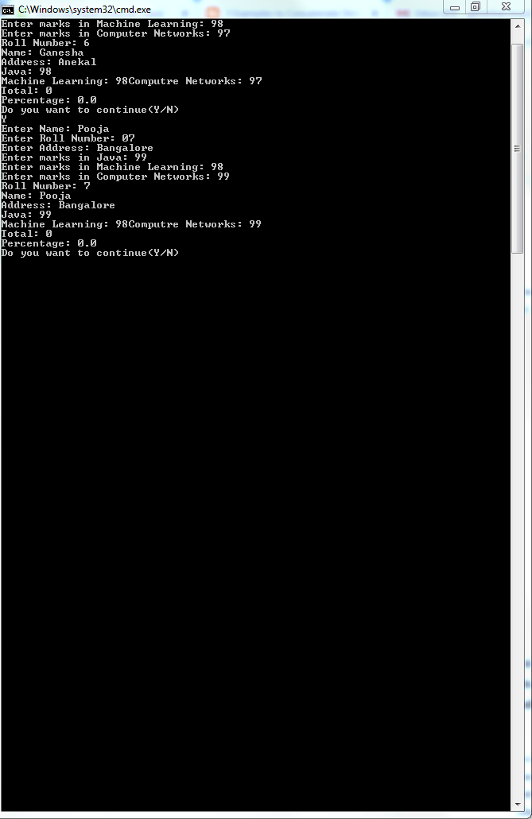

**Write a Java Program to implement method overloading using following scenario.Define a class with necessary members and methods to implement either addition or concatenation of two different inputs.**

**Code:**

import java.util.Scanner;

public class MethodOverloading{

public static void main(String args[]){

char ch;

do{

Scanner SC = new Scanner(System.in);

Overload ob=new Overload();

ob.add();

ob.add(10,10.2);

ob.add("a",10);

ob.add(10.2,'a');

System.out.println("Enter your choice");

ch=SC.next().charAt(0);

}while(ch=='y' || ch=='Y');

}

}

class Overload{

void add(){

System.out.println("No parameter");

}

void add(int a,double b){

System.out.println("Sum of integer and Double "+(a+b));

}

void add(String a,double b){

System.out.println("Sum of String and integer "+(a+b));

}

void add(double a,char b){

System.out.println("Sum of Double and Character "+(a+b));

}

}

**Output:**

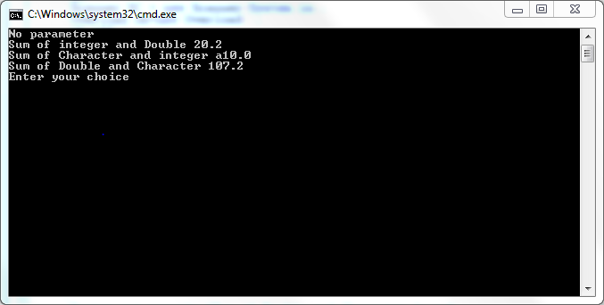

**Write a java Program to implement basic mathematical operations.**

public class JavaExample

{

int add(int num1, int num2)

{

return num1+num2;

}

int add(int num1, int num2, int num3)

{

return num1+num2+num3;

}

int add(int num1, int num2, int num3, int num4)

{

return num1+num2+num3+num4;

}

public static void main(String[] args)

{

JavaExample obj = new JavaExample();

//This will call the first add method

System.out.println("Sum of two numbers: "+obj.add(10, 20));

//This will call second add method

System.out.println("Sum of three numbers: "+obj.add(10, 20, 30));

//This will call third add method

System.out.println("Sum of four numbers: "+obj.add(1, 2, 3, 4));

}

}